**Assignment 18.3 Spark**

**Problem Statement**

**1) Considering age groups of < 20 , 20-35, 35 > ,Which age group spends the most amount of money** travelling.

**val usr30 = sqlContext.sql(""" Select count(id) idd , sum(T.**tariff**) AmountSpend,agelimit from (SELECT H.id ,T.**tariff **, case when age <= 20 then '<20' when age >= 21 and age <= 35 then '21-35' when age >= 36 then '>35' else 0 end as agelimit FROM Holyday H join Users U on U.id=H.id join Transport T on T.transport=H.transport) A group by agelimit """).limit(1)**

**usr30.show**

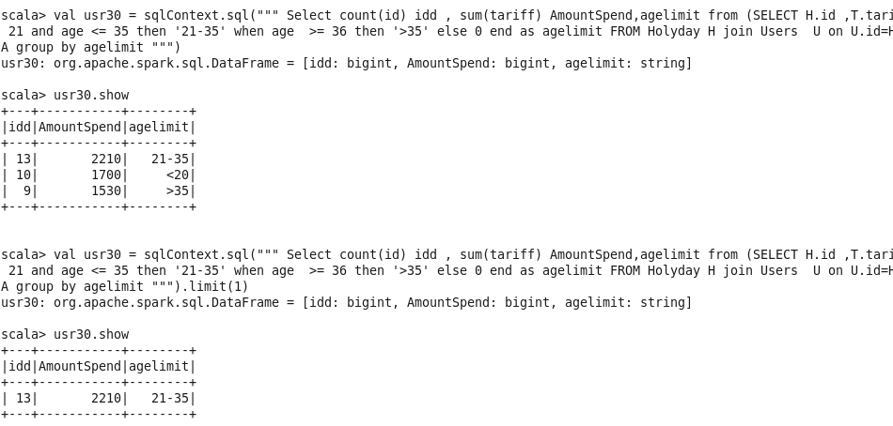

**2) What is the amount spent by each age-group, every year in travelling?**

val usr30 = sqlContext.sql(""" Select count(id) idd , sum(tariff) AmountSpend,year,agelimit from (SELECT H.id ,T.tariff ,H.year, case when age <= 20 then '<20' when age >= 21 and age <= 35 then '21-35' when age >= 36 then '>35' else 0 end as agelimit FROM Holyday H join Users U on U.id=H.id join Transport T on T.transport=H.transport) A group by year,agelimit order by year """)

